Institutional Affiliation
Professor’s Name
Student’s Name
Date

Brief description.
This project involves developing a work breakdown structure for expanding a business to new location.it was assumed that business is well developed and it needed to expand to international locations. The expansion preparation was to take place within six months within a specific budget.
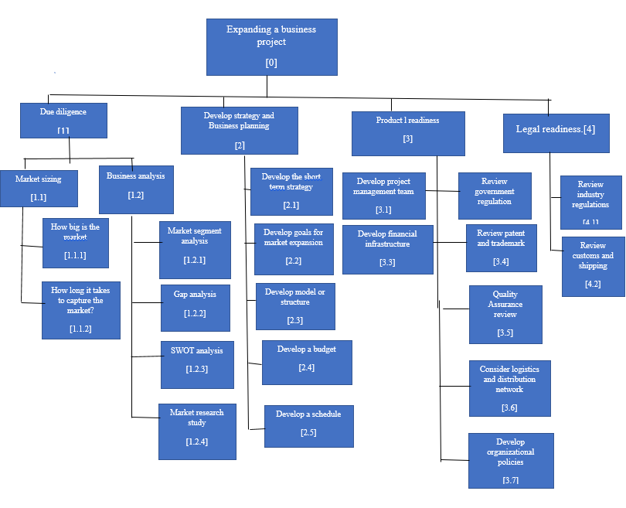
Review industry regulations
[4.1]
Review customs and shipping
[4.2]
Consider logistics and distribution network
[3.6]
Develop organizational policies
[3.7]
Develop financial infrastructure
[3.3]
Develop project management team
[3.1]
Product l readiness
[3]
Develop a budget
[2.4]
Develop a schedule
[2.5]
Develop strategy and Business planning
[2]
Market sizing
[1.1]

Market segment analysis
[1.2.1]
Quality Assurance review
[3.5]
Review patent and trademark
[3.4]

Review government regulation
[3.2]
Develop model or structure
[2.3]
Develop the short term strategy
[2.1]
Develop goals for market expansion
[2.2]
Market research study
[1.2.4]
SWOT analysis
[1.2.3]
Gap analysis
[1.2.2]
Business analysis
[1.2]
How big is the market
[1.1.1]
How long it takes to capture the market?
[1.1.2]
Expanding a business project
[0]
Legal readiness.[4]
Due diligence
[1]

